# ASSIGNMENT

**Submitted**

**By**

**DHEERAJ SHARMA**

**Roll Number: 2023A1R112**

**Semester – 1st**

**Department: CSE**





# Model Institute of Engineering &Technology (Autonomous)

(Permanently Affiliated to the University of Jammu, Accredited by NAAC with “A” Grade)

Jammu, India

2023

**1. Write the program for finding duplicate elements in array**

#include <stdio.h>

void duplicate(int arr[], int size)

{

printf("Output: ");

for (int i = 0; i < size; i++)

{

for (int j=i+1;j<size;j++)

{

if (arr[i]==arr[j])

{

printf("%d ",arr[i]);

break;

}

}

}

}

int main()

{

int arr[]={1,1,2,2,1,3,4,3,1,2,5,6};

int size=sizeof(arr)/sizeof(arr[0]);

printf("Input Array: ");

for (int i=0;i<size;i++)

{

printf("%d ",arr[i]);

}

printf("\n");

duplicate(arr,size);

return 0;

}

OUTPUT:

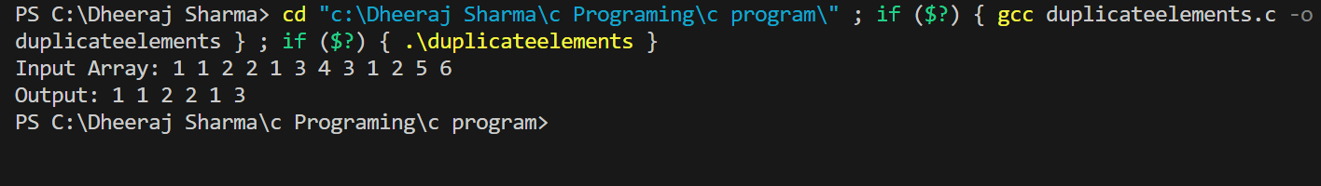

**2. Write the program for finding largest of three numbers in all methods.**

**(using ternary, elseif, nested if)**

//Using Ternary Method:

#include<stdio.h>

void main()

{

int a,b,c,big ;

printf("Enter three numbers:");

scanf("%d %d %d", &a,&b,&c);

big =a>b? (a>c? a:c) :(b>c?b:c);

printf("The largest number is: %d\n",big);

}

//Using elseif:

#include<stdio.h>

void main()

{

int a,b,c;

printf("Enter three numbers:");

scanf("%d %d %d",&a,&b,&c);

if (a>=b&&a>=c)

{

printf("The largest number is: %d\n",a);

}

else

{

if(b>=a&&b>=c)

{

printf("The largest number is: %d\n",b);

}

else

{

printf("The largest number is: %d\n",c);

}

}

}

//Using Nested If:

#include<stdio.h>

void main()

{

int a,b,c;

printf("Enter three numbers:");

scanf("%d %d %d",&a,&b,&c);

if(a>=b)

{

if(a>=c)

{

printf("The largest number is: %d\n",a);

}

else

{

printf("The largest number is: %d\n",c);

}

}

else

{

if(b>=c)

{

printf("The largest number is: %d\n",b);

}

else

{

printf("The largest number is: %d\n",c);

}

}

}

OUTPUT:

